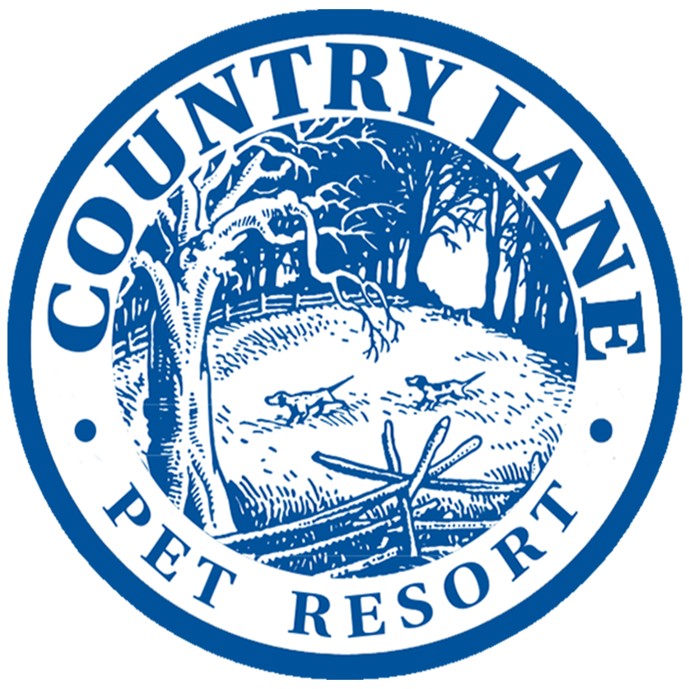
B o a r d i n g A g r e e m e n t
2722 Taunton Road East, RR#4, Bowmanville, Ontario, L1C 3K5 (905) 263-8539

Owner First Name _____________________________________ Last Name _______________________________________

Address __________________________________________________________________________________________________

City ___________________________________________________ Postal Code ____________________________________

Telephone Home________________________________________ Work_____________________________________________

Cell # 1 _______________________________________________ Cell # 2 ___________________________________________

Email _______________________________________________ Referred by _________________________________________

Emerg. Contact / Relation _______________________________________ Number ________________________________

Dogs Name ___________________________________ Breed ______________________________________________________

Colour __________________________________ Age ________________ Sex ______________ Spayed/Neutered

Vet Clinic ________________________________________________________________________________________________

Vet Expense Limit _________________________________ Previously boarded at another facility Y N ?

Please specify under what medical circumstances you would like us to contact you/your emergency contact:
(please note we will always contact you or the emergency contact if we feel necessary)
a) Only issues that require my dog to be picked up or taken to the vet
b) Any issue that persists (example - diarrhea lasting 3+ days, ear infection)
c) Any issue at all no matter how serious (example - cut nail, poor appetite)

Feeding Amount – am _________________ pm ________________ Brand of Food________________________________
(please pre-measure kibble to ensure there is enough – raw is to be prepackaged)

Other feeding instructions:_________________________________________________________________________________

How is your dog with people / dog’s personality?____________________________________________________________

___________________________________________________________________________________________________________

Does your dog like other dogs? Y N If NO explain:_________________________________________________________

Does your dog have food or toy aggression? _________________________________________________________________

Has your dog EVER responded aggressively/bitten/damaged a DOG or PERSON before? Y N

If yes, please explain _______________________________________________________________________________________

ANY health issues/medication? Y N If yes, please explain________________________________________________

Is your dog okay with being bathed/having ears/feet touched?_______________________________________________
(only will bath in the event your dog has an accident/soils run)

In the event your dog gets diarrhea, are we able to fast and/or add our in house supplements? Y N
(provides micro and trace elements, immune boosting probiotics, digestive and metabolic enzymes, omega fatty acids and is rich in highly digestible bio-available plant-based amino acids) Feed- sentials / Sunday Sundae / Sh-emp

Multiple Dogs Only
Would you like to book a double or single occupancy run(s)? Double Single
Can your dogs be fed together? Y N If no, state reason:__________________________________________________

New Client Deposit Date ______________________________ Form of Deposit Debit Credit Cash

This is a Contract between Country Lane Pet Resort and the pet owner whose signature appears below (hereinafter called "Owner").
1. Owner agrees to pay the rate for boarding in effect on the date pet is checked into Country Lane Pet Resort.
2. Owner further agrees to pay all costs and charges for special services requested and all veterinary costs for the pet during the said pet is in the care of the Country Lane Pet Resort.
3. Owner further agrees that the pet shall not leave Country Lane Pet Resort until all charges are paid to Country Lane Pet Resort by Owner.
4. By signing this Contract and leaving his pet with Country Lane Pet Resort, Owner certifies to the accuracy of all information given about said pet. Owner also gives Country Lane Pet Resort the right to request medical information from veterinary establishment specified by Owner, as well as utilize information given by Owner for the sole purpose of caring for the Owners pet.
5. Country Lane Pet Resort shall exercise reasonable care for the pet delivered by the Owner to Country Lane Pet Resort for boarding. It is expressly agreed by Owner and Country Lane Pet Resort that Country Lane Pet Resort's liability shall in no event exceed the lesser of the current chattel value of a pet of the same species or the sum of $200.00 per animal boarded. The Owner further agrees to be solely responsible for any and all acts or behavior of said pet while it is in the care of the Country Lane Pet Resort.
6. Owner specifically represents that he or she is the sole owner of the pet, free and clear of all liens and encumbrances.
7. Owner specifically represents to Country Lane Pet Resort that the pet has not been exposed to rabies or distemper within a thirty-day period prior to boarding.
8. All charges incurred by Owner shall be payable upon pick-up of pet, or when billed by Country Lane Pet Resort at the address listed on contract. Country Lane Pet Resort shall have, and is hereby granted, a lien on the pet for any and all unpaid charges resulting from boarding pet at Country Lane Pet Resort. The Owner hereby agrees that in the event the boarding charges are not paid when due in accordance with this contract, Country Lane Pet Resort may exercise its lien rights upon ten days written notice given by Country Lane Pet Resort to Owner by certified mail to address shown on contract. Country Lane Pet Resort may dispose of pet for any and all unpaid charges, at private or public sale, in the sole discretion of Country Lane Pet Resort, and Owner specifically waives all statutory or legal rights to the contrary. If such sale shall not secure a price adequate to pay such costs of board or other charges delinquent, plus costs of sale, then Owner shall be liable to Country Lane Pet Resort for the difference. All monies realized by Country Lane Pet Resort at such sale, over and above the charges due and costs of sale, shall be paid by Country Lane Pet Resort to Owner.
9. If pet becomes ill or if the state of the animals health otherwise requires professional attention, Country Lane Pet Resort, in its sole discretion, may engage the services of a veterinarian or administer medicine or give other requisite attention to the animal, and the expenses thereof shall be paid by the Owner. PREVENTION of disease/parasites is the pet owner’s responsibility. Country Lane Pet Resort cannot be held responsible for any losses incurred in the event that a pet contracts a disease or parasite while in their care.
10. This Contract contains the entire agreement between the parties. All terms and conditions of this Contract shall be binding on the heirs, administrators, personal representatives and assigns of the Owner and Country Lane Pet Resort.
11. Any controversy or claim arising out of or relating to this contract, or the breach thereof, or as the result of any claim or controversy involving the alleged negligence by any party to this contract, shall be settled in accordance with the rules of the Canadian Arbitration Association, and judgment upon the award rendered by an arbitrator may be entered in any Court having jurisdiction thereof. The arbitrator shall, as part of his award, determine an award to the prevailing party of the costs of such arbitration and reasonable attorney's fees of the prevailing party.

Pet Owner ___________________________________________________________________

Date _________________________________________

